Chem 154 Notes
Christopher Kalitin

Sep 10: Valence Electrons, Zeff, Ionization Energy
Only s & p shells in the highest n shell (eg. 3p^2, only 3 is used) are valence electrons. These are involved in bonds. This is why a triple bond is the strongest bond.

Full valence shells are not reactive, 8 electrons. Noble gasses. The farthest column on the periodic table effectively has 0 free electrons.

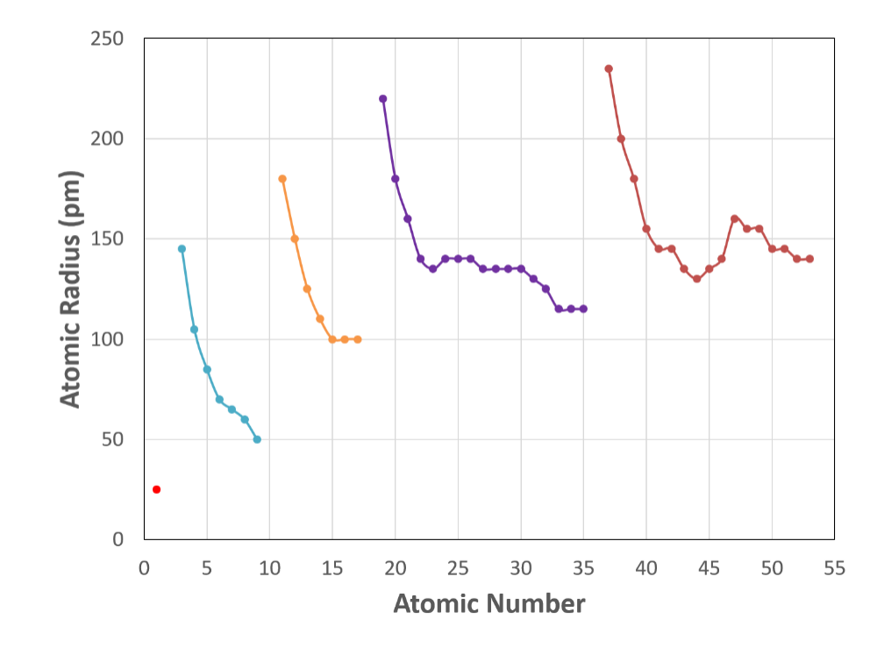
Only the electrons in the highest energy shell of the NEUTRAL ATOM are counted as valence electrons. Eg. Li+ (2 valence electrons in shell 1) actually has 0 valence electrons, since they’re in shell 1 which is lower than neutral lithium highest energy shell.

Atomic radius = internuclear distance / 2
Is internuclear distance always equal?

X-ray diffraction can be used to determine internuclear distance. We use H2 to get atomic radius, it allows us to divide by 2. Not true of other molecules.

For any given atom, its cation will always be smaller. Anions are always larger. Why?

N 3- is atomically bigger than F -
Effective Nuclear Charge (Z eff) / Coulomb’s Law:
Valence electrons get less positive charge from the nucleus because they’re farther and some of the charge is screened by other electrons.

Z effective, effective nuclear charge.

The electron core screens some of the charge, the valence shell (highest energy) feels less positive charge.

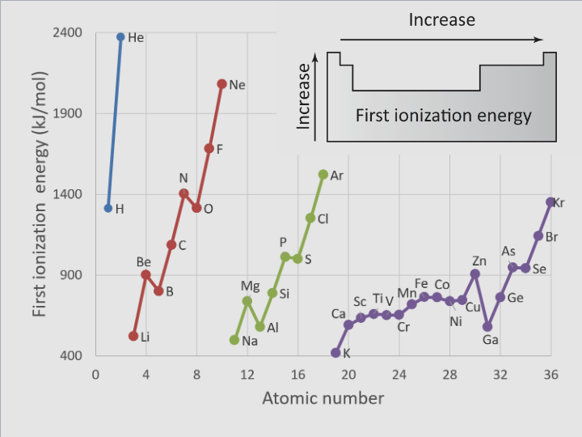
Ionization energy: Energy required to remove a single electron from a gaseous atom.
For solids, we call the valence electrons the valence band. Ionization energy is the energy to remove an electron from the valence band.

Electron affinity is the energy gained by adding a single electron to an atom.

Sep 12:

Higher valence shell = large radius.

When electrons are added, ie. electron affinity, there is a new electron-electron repulsion force. This has to be less than the “activation energy” to add the electron.

Ionization energy is the gap between E=0 dissociation limit and the lowest orbital. E=0 is asymptotically approached as the number of orbitals increases?

Only the core electrons screen (in phys 157), valence electrons screen far less.

Left to right, valence electrons are increasing in count. So, ionization energy is increasing?! Z (nuclear energy) is increasing.

Top to bottom. Valence shells are increasing in count, so Z is increasing (Protons increasing). IE decreasing. Radius is decreasing!? Z effective is also increasing because while Z is increasing, the screening is increasing at a lower rate. Eg. the closest orbitals screen most.

Orbitals can be used to rationalize everything in chemistry. Quantum mechanics is the fundamental law behind all the behaviors we observe.

Electronegativity:
Electronegativity is the ability of an atom to attract electrons.
Electronegativity is roughly increasing to the top-right of the periodic table.
FOCIN BrISCH <- highest electronegativity values. Just need to know order not values.
Bond length is the distance at which atoms have the lowest potential energy. Electrons in one atom are attracted to the other atom in a bond, so potential energy actually decreases until you get to a certain distance (bond dist) when it starts increasing again and the forces of the two positive nuclei supercede the forces of the electrons being attracted to the opposite nuclei.

Low electronegativity favors covalent bonds, high favors ionic bonds.
Delta EN > 1.7 = ionic bonds. Difference between EN of two atoms.

In covalent bonds, electrons are not shared evenly. Ionic = equal. Use electronegativity difference to determine this. Ie. if an element is more positive than the other, it has less electron density.

Homework Notes:
When drawing Lewis Dot Structures:
- Add up initial valence electrons of all atoms and make sure this adds up to the number of valence electrons (including bonds) in the final structure.
- Whichever atom needs more bonds to form an octet goes in the middle, eg. lowest valence electron count.
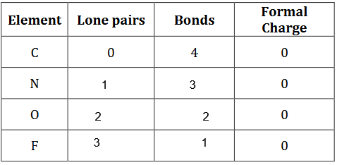
Atoms have a natural number of bonds and free electron pairs that they want to have in compounds.
This table makes it far easier to draw Lewis structures.

Moving left to right on the periodic table decreases atomic radius because the increased charge of the nucleus is larger than the decrease in charge with the added electron. Nucleus charge is growing faster than electron charge - net Zeff is increasing. Higher nucleus force with a slow increase in electron shielding in the valence shell.

The group that forms stable +2 ions is group 2. This is correct for any +n charges that are especially stable. Eg. +1 is far less stable than +2, so you see where the line is.

Sep 17:

Electron Affinity = energy released when an electron is added to a neutral atom.

Explicit Charge Transfer: eg. CO. Two electrons go from Oxygen into a bond with C. So instead of one electron from each atom making a bond, both come from O. Dative Bond.

Formal charges are just bookkeeping, in reality you have situations like electron transfer.

Arrow pushing. Push electrons to another atom and rearrange so that each atom still has an octet. Method for creating new Lewis structures. The bonds can also alternate - resonance structures?

Lewis structures are approximations of reality.

Exceptions to Octet Rule:
- Group 13: Sextet
- Radicals: Molecules with an off number of electrons. A single unpaired electron. Eg. NO, nitrogen has 7 electrons
- Radicals are extremely reactive, that one electron really wants a bond
- Hypervalence: Elements on the third row and below and have more than 8 electrons. Only third row?
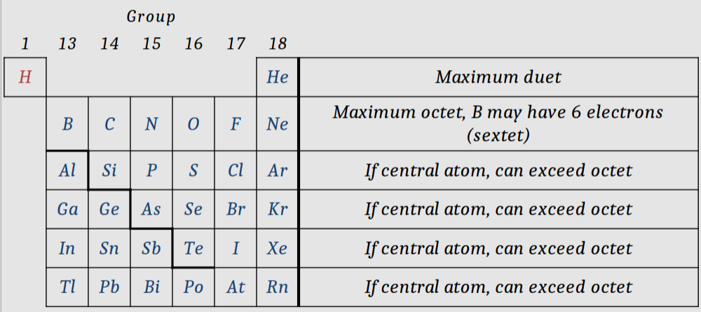
For hypervalence, Electrons in pairs go up to the 3d orbital, now you have eg. 5 single electrons that can be paired. There’s an energy cost to this. Bonds have more energy than just pairs, so you’re net positive in a molecule.

They don’t go to the 4s orbital even though its lower energy because shape matters too.

Bond distance allows us to determine bond types. Bonds that oscillate between single and double have slightly lower distance.

Sep 19:
Formal charge = valence electrons - nonbonding electrons - bonds

If multiple structures are possible, only do those that have the net formal charge you require.

Bonds order = average number of electron bonds per atom to atom bond.
Eg. If you have a double bond and a single bond, the bond order is 1.5. Two atom-to-atom bonds, but 3 electron pair bonds.

Resonance structure = Same structure of an atom but bonds switch. Eg. oscillate between 1 and 2 electron pairs in a bond.

When drawing resonance structures, we do not move nuclei (atoms).
So, H - O and O - H are not resonance structures, these are different.

Hyper valence only occurs if it results in a net formal charge closer to 0!
Also, comparing different Lewis structures, go with the NFC closest to 0.

Bond order is inversely correlated with bond distance. It’s simple. More bonds = closer.
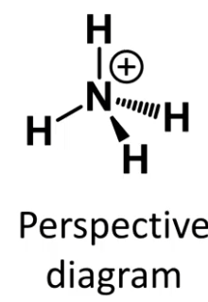
VSEPR: Valence shell Electron Pair Repulsion

In atomic perspective diagrams, Bold line means towards you, dashed means away.

In VSEPR diagrams you don’t need to show lone pairs or multiple bonds.

You can have Axial and Equatorial bonds. They have slightly different bond distances even if they are the same atom.

Linear, Trigonal planar, Tetrahedral, Trigonal Bipyramidal, Octahedral.
Angles: 180, 120, 109.5, 120/90, 90
Tetrahedral = 109.5 is the only thing you need to memorize.
Bent = Trigonal Planar missing one

Atoms want to change formal charge as little as possible!

Lab Sep 23 Notes:
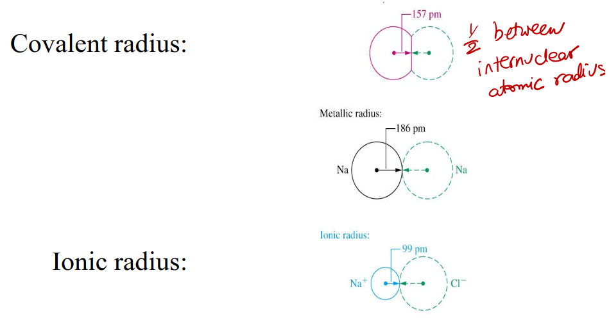
Sep 24 Lecture:

Trigonal Planar has three pairs. When two of these pairs are of a bond, and one is a lone pair, you get the bent VSEPR shape.

For Tetrahedrals with 3 bonds and a single pair, you get the shape of NH3.
Trigonal Pyramid.
Octahedrals (6 bonds) with a lone pair are a square pyramidal shape.

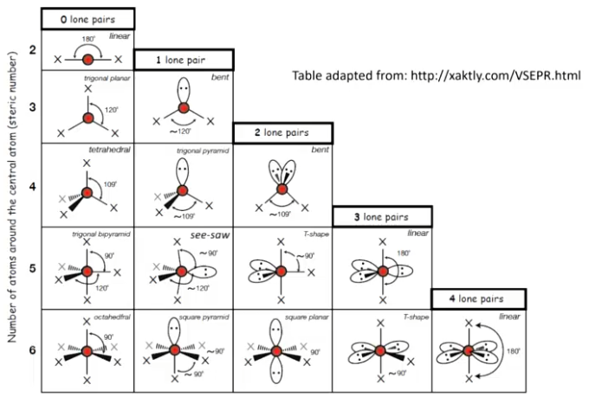

The process is finding how many electron pairs an atom has, choosing the appropriate shape (eg. for 4, Tetrahedral). Then, given the number of lone pairs, draw the VSEPR shape.

Be careful with the number of electron pairs, it’s only those that are on an atom. Eg. for a double bond, your atom only has the two closest to it. Ie. double bonds don’t matter, count them as just one.

Lone pairs repel each other more than bonding pairs repel each other. Bonding pairs are stuck between two atoms, lone pairs can move around more.

<120 degree angles are called “bad” contracts. Overlapping orbitals.

Electrons want to be as far away from each other as possible. When building VSEPR diagrams, put the lone pairs in the positions that distance themselves the most, highest angle between lone pairs and bonds!
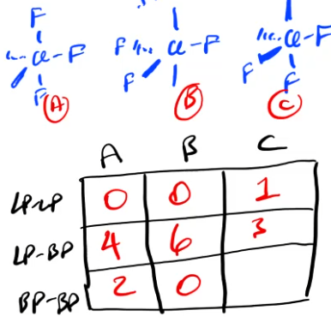
You can rank the number of LP-LP, LP-BP, and BP-BP bonds in different VSEPR structures. LP-LP is the worst, BP-BP is “best.” So, rank the structures by which have the most LP-LP/LP-BP.

Here, it goes A > B > C. A is preferred.

Lone pairs like the Axial Position.

Sep 26 Lecture Notes:
If you have two dipoles that are opposed to each other (eg. CO2), the individual bonds are polar, but not the net molecule. It’s vector math.

Intermolecular forces are bonds between molecules, not chemical bonds.

London Dispersion Forces: In an instantaneous moment, there may be a fluctuation in the position of electrons in an atom. This causes it to become a little magnet, an instantaneous dipole. When next to other atoms, the electromagnetic forces attract them together.
Stronger attractive forces between atoms, means a higher melting point.

Larger molecules have more polarizable atoms, which means the dispersion area of the London Dispersion Forces is higher, so a higher melting point.

Dispersion only applies to molecules that don’t have greater forces, eg. dipoles.

Dispersion is additive, you can make a very long hydrocarbon and have very high attractive dispersion forces.

You need more space for more dispersion forces, ie. higher attractive force.

Oct 1 Lecture Notes:

Dipole-Dipole interactions: The dipoles of molecules want to be aligned positive to negative. Eg. H2O, you can imagine it.

Charge-dipole interactions: Dipoles want to be aligned to ions around them. Eg. The negative end of H2O being attracted to Na+.

These interactions are mostly random because the forces can’t overcome all other forces, but they tend toward having impact.

Hydrogen bonding:
The negative dipole of a molecule being attracted to the positive dipole of another molecule (the hydrogen is a positive positive). Hydrogen bonded to an electronegative atom.

O-H / N-H bonds are common with Hydrogen bonding. Fluorine and Chlorine don’t want to?

To have hydrogen bonds you need hydrogen (positive) to be directly bonded to an electronegative atom (Oxygen or Nitrogen). You need that bond itself to have a sufficient difference in charge. + and fluorine (Jeff)

All atoms that have valence electrons have London dispersion forces.

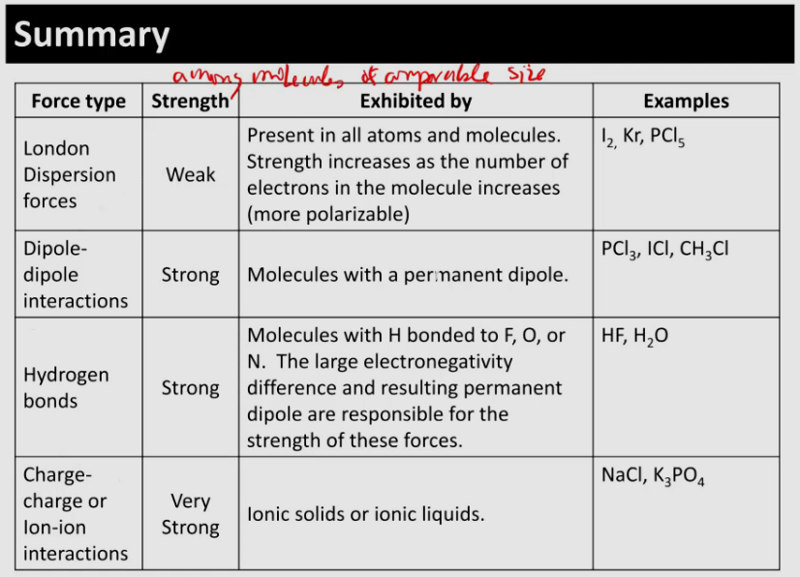

Detergents are often long chain hydrocarbons bonded to an electronegative molecules. The hydrocarbon has many hydrogens, so it has high London dispersion forces, attracting other molecules. The negative molecule is attracted to water, negative dipole attracted to hydrogen. This makes the compounds attracted to the Hydrocarbon soluble.

For thermodynamic equilibrium, there must be no net macroscopic flows. Eg. water evaporating is a macroscopic flow.

In practice, equilibrium means the system is robust (no changes) on our time scale.

Oct 3 Lecture Notes:

Intramolecular attraction forces are the difference between gas and liquid. Attraction wins out against movement.

Dispersion forces are always present.

All phase diagrams have solid on the top. In the limit.

Critical fluid can be used as a solvent. Lower the temperature, and it turns to gas.

Vapor pressure: Pressure exerted by a vapor in thermodynamic equilibrium with its condensed phases. It has to be on one of the lines on the phase diagram for gas and liquid to coexist.

Vapor pressures can be used to compare intermolecular forces.

Intra = small, Inter = big
Intra = within molecules, Inter = between molecules

Hydrogen bonds only occur with NOF.

Lower vapor pressure = stronger molecular attractive forces.

Dipole-Dipole forces are NOT always greater than dispersion forces.

Vapor pressure is the pressure being exerted back on the liquid.

On phase diagrams, the pressure should be the pressure of the substance, not the atmosphere.
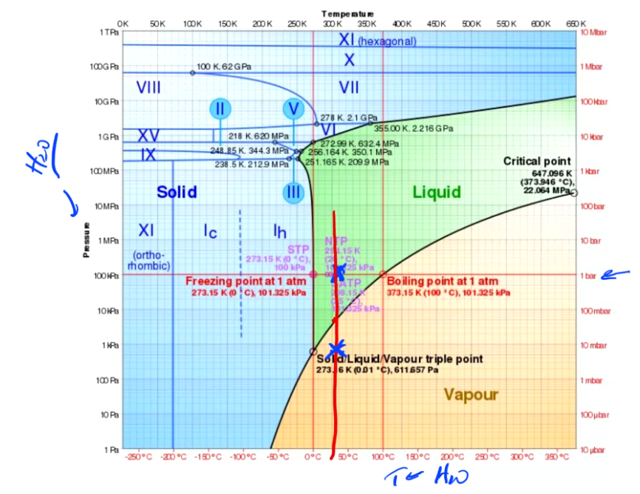
Vapor pressure refers to the pressure the gaseous substance is exerting on the liquid substance. Eg. vapor pressure of water in a cup is correlated with humidity.

For evaporation to occur, the vapor pressure from gaseous water has to be higher than the point at which for a given temperature, the water could be gaseous.

A puddle is not an equilibrium! It is evaporating!

Oct 8 Lecture:
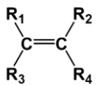
Shorthand notation for organic molecules:
Intersections are Carbons, Covalent bonds are drawn as lines. Each Carbon atom has enough bonded H atoms to get a formal charge of zero. We also put a bend in the lines when the VSEPR shape is tetrahedral/bent.

R represents an unknown variable, it could be any molecule.
We use it when we only care about a particular bond.

Everything is functional groups in chemistry.

You have to memorize these functional groups:
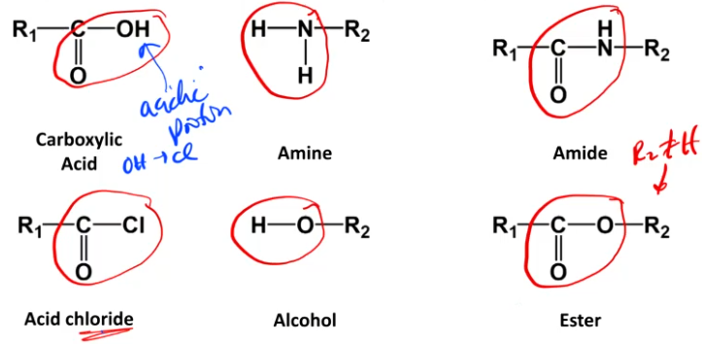

Two types of polymers: Condensation polymers, addition polymers

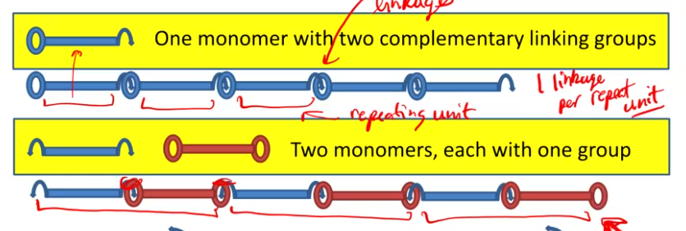

Think about it in terms of repeat units. In the top diagram, there is one link per repeat unit, in the lower diagram, there are two links per repeat unit (because the repeat unit has 2 monomers).

To show a repeat unit we put it in square brackets and write “n”. Square brackets go through bonds. The groups are not shown because they don’t perfectly repeat. Ie. the R at the end of a chain.

Oligomer = small number of repeat units, polymer = large number. Dimer = 2, Pentamer = 5.

All proteins are polyamide polymers.

Condensed polymers: when two monomers join, a small byproduct can be created. Usually water or hydrochloric acid. An amide linkage is formed in the place of the parts of the byproduct that were on the two monomers.

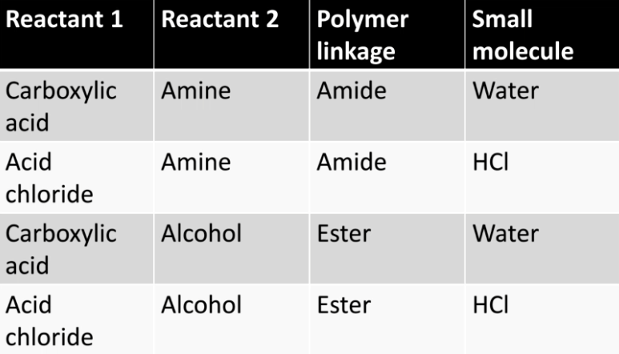
Oct 10 Lecture:
Condensation reaction = you condense out a molecule.

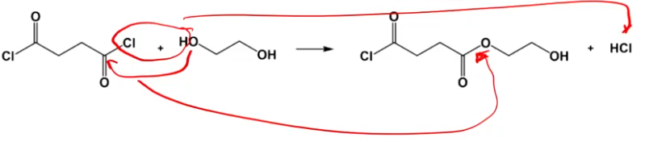
There’s rotations around all single bonds.

Acid + Amine = Amide linkage
Acid + Alcohol = Ester linkage

You need to write in the hydrogens in shorthand diagrams if they are bonded to anything but carbon.

Radical = species with an unpaired electron

With double bonds between atoms, both bonds are not equal.
One is a sigma bond, it binds the atoms, a very strong bond.
Other is a pi bond, weaker and affects the geometry
There are two pi bonds in a triple bond.

One of the electrons from the pi bond bonds with the free electron in a radical. The other electron from the pi bond is free. Ie. destroy a double bond so an extra electron can be used to bond with a radical.

Addition is this process of bonding with a radical.

You have to produce a radical. They aren’t too stable. Radicals terminate when they meet another radical. This is how addition polymers terminate.

If there are only carbon-carbon linkages, the polymer must be additive.
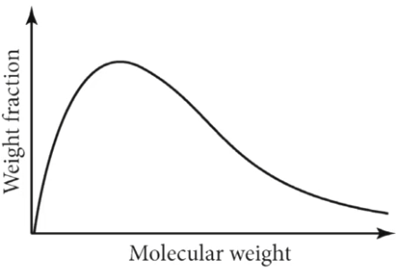
Oct 15 Lecture:

Polymers form chains slightly randomly, so you get a distribution of lengths.

Weight fraction = mass of polymer with i units divided by total mass
Mole fraction is different

Longer chains are mechanically stronger than small chains. Eg. more opportunity for dipole-dipole interactions, or anglement (curling up chains, spaghetti).
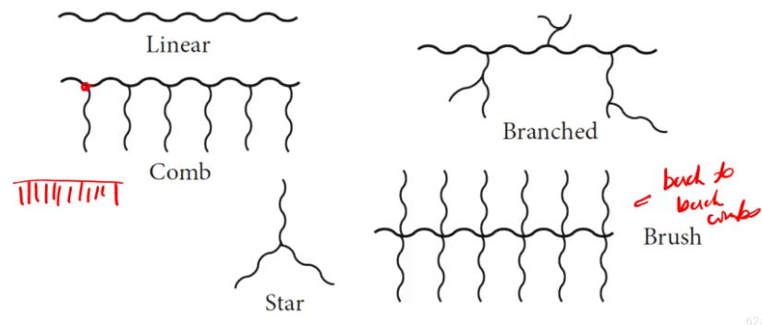
Branching can enhance chain entanglement, if all else is equal (ie. molar mass).

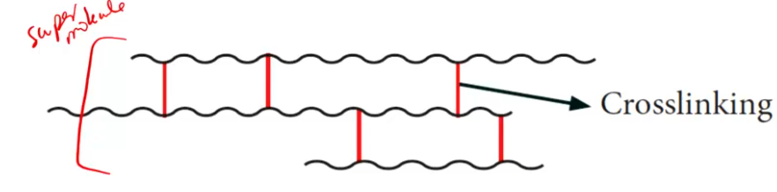
Cross linking is bonds between several linear polymers next to each other. Eg. Vulcanized rubber has sulfur between the rubber chains.

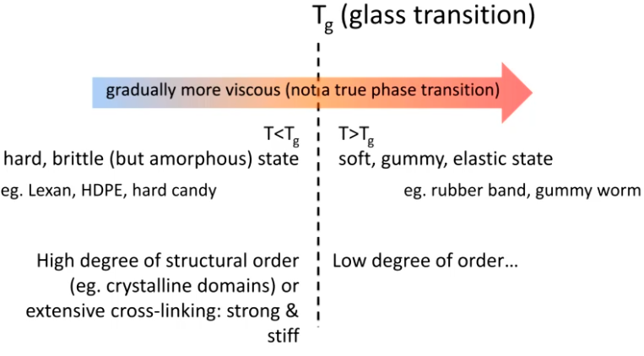
A glass is a solid with no regular repeating structure. Polymers have a glass transition point. Eg. rubber band vs. wood.

Oct 17 Lecture:

3d printer filament is above the glass transition temperature. You don’t want it to be liquid or solid.

Radicals can attach to the center of a chain, making a branch.

LDPE is branched, HDPE is linear. High-density polyethylene.
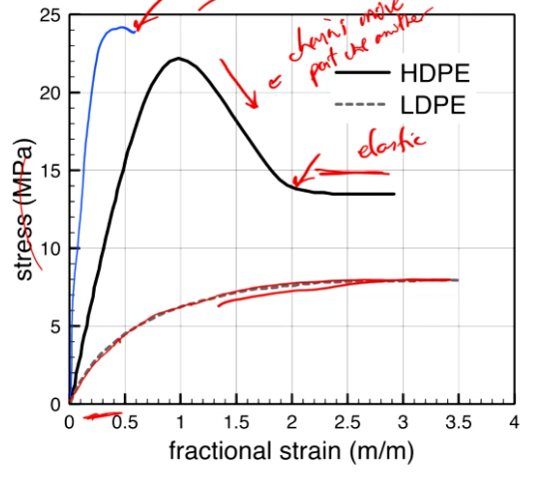
Stiffer polymers are more vertical on the graph. Where the slope is negative for HDPE, this is where you’re pulling on plastic and it starts to change color.

Branches need to have a group attached to them, with a chain going off another source chain. Otherwise, you just have a linear polymer with some groups as decoration.

1 atm = 760 mmHg
Ideal Gas Law: PV = nRT

Ideal gasses must have no intermolecular interactions.

PV = nRT is always an approximation to real gasses.

Oct 22:

Mixture of ideal gasses (add up mole counts):
PV = (n1+n2+n3+…)RT

Partial pressure is the pressure a gas would exert if it were alone. Eg. Only oxygen in the atmosphere.

If volume is fixed for ideal gasses:
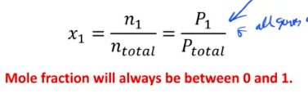

You have to convert grams to moles!!

All liquids have vapor pressure. This has to be considered in all questions.

PV = mRsT
PV = nRT
mRs = nR
m = nM where m = mass, n = moles, M = molar mass

Kinetic Molecular Theory tries to specifically describe ideal gasses. It says average kinetic energy is proportional to temperature, gas particles only act on each other when they collide, etc.

The ideal gas law relates the energy of particles with two separate equations.
Both PV and nRT are measures of energy that are equal to each other.

Temperature and molecular mass is what determines the average molecular kinetic energy and the mode of velocity. Ie. where the peak is on the velocity distribution curve.

Kinetic energy at a given temperature of any atoms/compounds is equal, because T is proportional to kinetic energy. However, velocity is not the same because KE = 0.5mv^2

Ideal gasses (based on kinetic molecular theory) only work at a certain pressure range. If pressure is too high, interactions between particles start to have higher effects. Van der Waals equation comes in here.
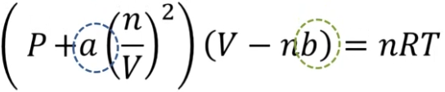
Van der Waals equation:
n*b takes into account the volume of the particles themselves
a*(n/V)^2 takes into account attractions between particles, this affects pressure.

Oct 24:
Compressibility factor is Z = PV/nRT
For ideal gasses, Z = 1.

Heavier particles deviate from ideal behavior faster than lighter particles. “Fast” in terms of what pressure they deviate at. The heavier particle will also have higher values for a and b in the Van der Waals equation.

Thermodynamics!

Thermodynamics has a distinction between system and surroundings. Combining both of these, we get the universe. Where you draw the distinction is important.

Extensive properties scale with size, intensive properties do not. Eg. Heat vs. temperature.

Caloric thinking (1800s): “objects hold heat”
Objects in fact hold energy, and heat is just the flow of energy.

Heat was measured in calories and energy was measured in joules. We had two ununified theories.

In chemistry we have the opposite convention as physics for work. Negative work is lost energy, positive work is the system gaining energy.

dW = -PdV
Where dW = delta work, P = pressure, dV = change in volume

All of thermodynamics is differentials and integrals.

W = -Pe * dV can only be used when pressure is constant. Imagine the graph.
Pe = P external, external pressure acting on the system.

Final pressure of a piston freely expanding is equal to the external force acting on it. Ie. Most pistons stop at 1 atm.

R = 8.314 = J/(mol*K)
R = 0.0821 = atm*L/(mol*k)

Oct 28:
Van der Waals constants: https://sites.google.com/site/chempendix/van-der-waals-constants

Oct 29:

dU = q + w
This is the opposite sign that is used in physics.
“It’s going to be an unfortunate part of your life.” <- Integrate chem and phys so we have the same signs!!

Heat and work are both energy. This is the first law.

Oxygen is only produced at late stages of a star.

Equilibrium is a state that doesn’t depend on its history. It has constant thermodynamic variables, we don’t have to consider its entire history through the universe.

H = Enthalpy <- is this heat?
S = Entropy
G = Gibb’s energy

For a one-component closed system, if you have two thermodynamic variables, you can determine all the rest.

Adiabatic means no heat flow occurs.

Heat and work are path functions. Ie. different amounts of heat flow and work can accomplish the same energy change.

A process is reversible if the system remains at equilibrium throughout the entire process. Ie. you have such a small perturbation that the system recovers very quickly.

Always start with a net equation when doing problems!! Don’t do intermediary steps, you don’t need to, just one shot the equation and double check quickly. Quickly because it's a single equation.

In Chem 154 we only do constant external pressure problems.

Irreversible processes:
- Anything with friction
- Work happening with any difference between external and internal pressure. So, in reality all processes are irreversible
- Heat flow across any temperature difference.
- Stirring
- Mixing
- Chemical reactions not in equilibrium (Eg. acid-base are equilibrium, almost everything else is not)

In a combustion reaction, the system is the thing exploding. Energy is released from combustion, so it is losing all this energy. So, it is negative, losing energy.

Almost everything in physics (157) is reversible and ideal, this is different from what we do in chem 154.

Nov 3:

P = nRT has these three assumptions: reversible, ideal gas, isothermal.

Reversible always applies to isobaric reactions.

Qp = dU + PdV = dH
Delta U + Work = change in H (Change in enthalpy)

H = U + PV
H is in joules

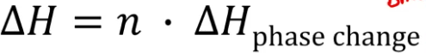
dH = n * dH phase change
dH phase change = enthalpy of phase change

Remember that dH = Q
If we have constant pressure, dH = H

Because dH is a state function, it is path independent.
So, if we want to find the dH for a specific process, if we can’t do it directly, we can go through an intermediary step.

Standard state is not STP, standard state is for pressure/concentrations, STP is for temp/pressure.

Standard state is used for determining dH_{f T}, the heat of formation for a substance from pure constituent elements.

Nov 5:
Standard state is the state that molecules appear at when at 1 bar, ~25c, etc.

Hess’s law:
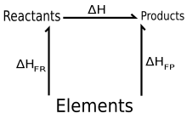

Formation reactions are those that have been found to have specific delta Hs of formation, that we can use in conjunction with each other to determine the heat of formation for a specific compound.

Formation reactions must be balanced, and the output must be a single mole. Here, only D works.
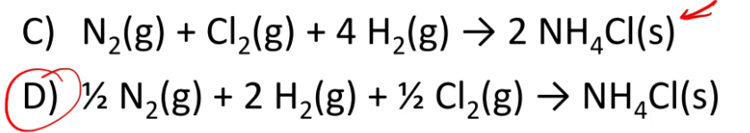

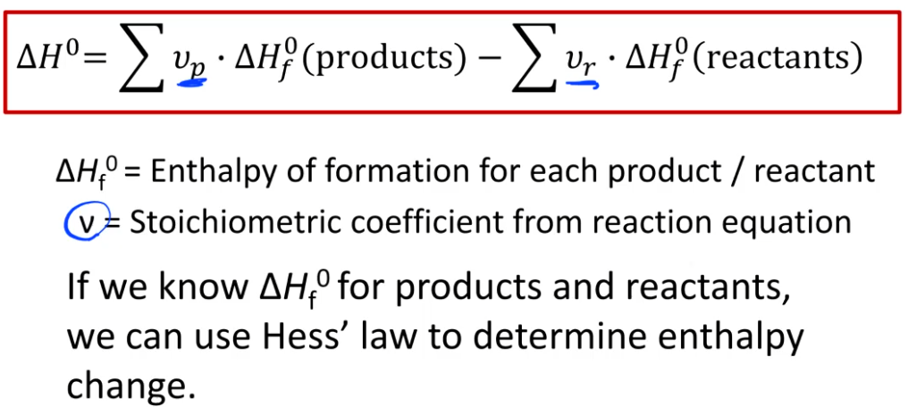
Formation reactions must be formatted at standard state, ie. instead of saying you required an O atom, you have to say you require ½ O2 (g).

dH_f = Heat of formation

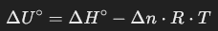

Remember! Because dH is usually given in kJ, you have to divide R by 1000, because its units are usually J/(K*mol).

Gasses are far more voluminous than anything else, so you can use PV=nRT on only the gas terms to find approximate change in volume.

H = U + PV
This is the definition of H and U.

Rhombic is a geometrical form of sulfur.

Breaking a bond requires energy (input), creating a bond releases energy (output).
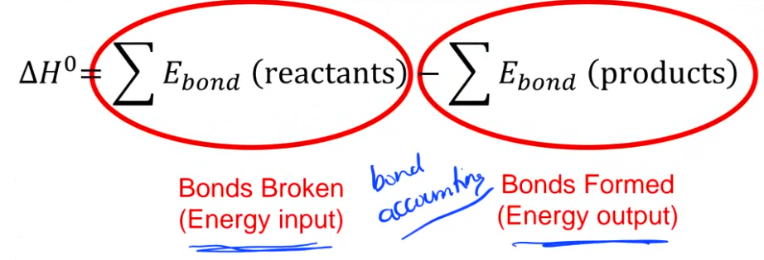
When doing bond accounting to find dH or the energy of a specific bond, always write it out in the format of the equation above.
dH = 1 mol(H-H) + 1 mol(Cl-Cl) - 1 mol (H-Cl)

Remember! If energy is released, dH is negative!

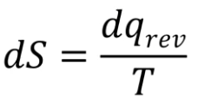
When doing bond accounting, you only need to consider what bonds are broken and created.

The q here must be reversible (delta Q sub rev).
We only know how to calculate S for reversible processes.

In chemistry, almost everything is irreversible, so we need a different way to calculate entropy.

Only if energy is transferred as heat does it induce a change in entropy, not work.
Heat and work are different.

Thermodynamics was developed before molecules.

If Qrev > 0, then dS > 0, then entropy increases.
If heat is absorbed, entropy increases!!

S = k Ln(W) <- Boltzmann equation
K = R/Na = 1.38 * 10^-23 J/K <- Boltzmann constant

Here, S is a macroscopic property while W is a microscopic property. This formula comes from statistical mechanics. This is where the idea of disorder comes from.

You can predict the laws of thermodynamics from statistical mechanics!?

You cannot take a molecule and measure its entropy, but if you take a collection of molecules, you can measure entropy. This is why it's a statistical property.

Nov 7:
Heat exchange over a finite temperature difference is one of the properties of an irreversible process.

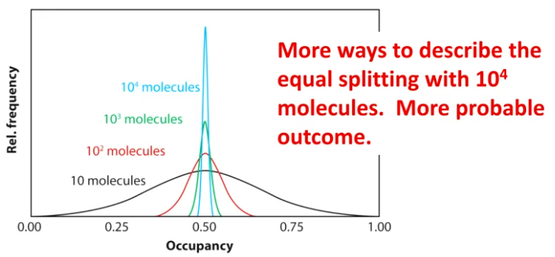
Entropy is a collective behavior. Random microscopic movements lead to bigger macroscopic trends.

Larger systems are less likely to have uncommon distributions!!!

Entropy only applies to a sufficiently large collection of particles!!

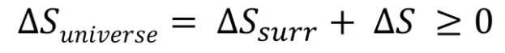

There is no fundamental proof for the second law of thermodynamics.

Irreversible processes lead to an increase in entropy.

At the microscopic level, you can reverse time and not notice any difference in behavior (imagine particles impacting each other in a closed system). However, at a macroscopic level you do not have this.

If a system is in equilibrium, you can’t tell if time passes!!
If everything is reversible, does time exist?

He was doing a PhD defense where they were looking at the first milliseconds of the big bang and were saying it's an adiabatic with constant temperature.

We treat the universe like an isolated system, is it expanding into anything?

dS = Qrev/T <- only applies to isothermal systems

Because the temperature of the system and temperature of the surroundings are different, there is a difference in entropy. The lower temperature thing gets a larger rise in entropy, so there is a change in the entropy of the universe.
This is why heat exchange over a finite temperature difference is irreversible!!!
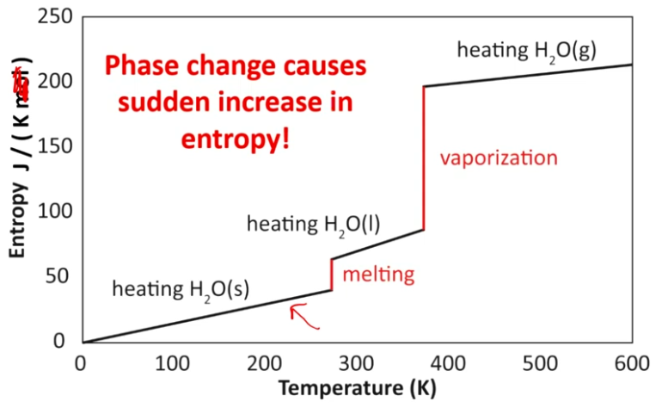
Entropy increases with temperature, volume, phase transition, etc.

The third law of thermodynamics gives an absolute reference point for entropy values. The entropy of a perfect crystal at T = 0K is zero.

Nov 11 Studying:
W = -nRT

Remember when working with given dH formation values to multiply by number of moles.

Enthalpy change only equals heat released when pressure is kept constant. Ie.
Delta Entropy (dH) = H (heat) = Q

When working with bonds & chemical reaction formulas, be sure to make sure the input is a single mole!! ONE MOLE!

Remember to write all negative signs!! Do this subconsciously and constantly!

Positive delta H = heat absorbed

Any substance at standard conditions that is pure has a standard heat of formation of zero.

Midterm Studying Notes
https://canvas.ubc.ca/courses/160899/pages/exam-information

Inter > Intra - Interstates go between states
Hydrogen Bonding > Dipole > London Dispersion Forces
- Remember Ionic

760 mmHg = 1 atm <- On formula sheet

Read Closer.

Give bond order as a range.

Bond order refers to an individual bond, don’t worry about other bonds on the atom. So, in a resonance structure if it can be a single or double bond (again, ignore everything else except to determine the resonance structure), the bond order is 1.5. However, the more likely structure is preferred, so give it as a range.

Hydrogen bonding only occurs with NOF. Nitrogen Oxygen Fluorine.

Hypervalent atoms can have more than 4 bonds!

Q = -mct
NEGATIVE!!

Watch out for units on Cp, if they’re J/(g*K), use grams!!

Diamonds are denser than graphite.
In a Lewis diagram, the negative charge should be on the most electronegative atom.

Think about size in terms of the highest occupied orbital.

Don’t include lone pairs on perspective diagrams.

Positive charges make an atom smaller than the atom with that charge normally.
Eg. Ca 2+ is smaller than Ar.

Nov 14 Lecture:

When dH is zero, this doesn’t mean dS is zero. Delta H of formation vs. change in entropy.

ΔG (Gibbs free energy) = ΔH - TΔS = Q_{irreversible} + W_{non PV}

Q_{irreversible} and W_{non PV} are both path variables while the left hand side is a state variable that is not path dependent. So, the proportion between Q and W can change, but their sum is constant.

If the process is reversible, we are left with ΔG = W_{non PV}
W_{non PV} is reversible.
So, we get a maximum value for ΔG from W_{non PV}

Electrical work is an example of non-pv work.

ΔG = -TΔS_{universe}

ΔG < 0 - Spontaneous reaction
ΔG = 0 - At equilibrium
ΔG > 0 - Non-spontaneous reaction

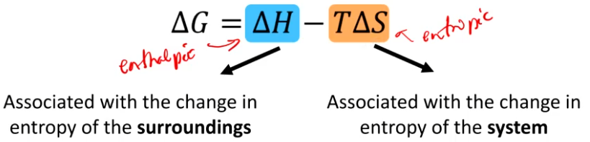
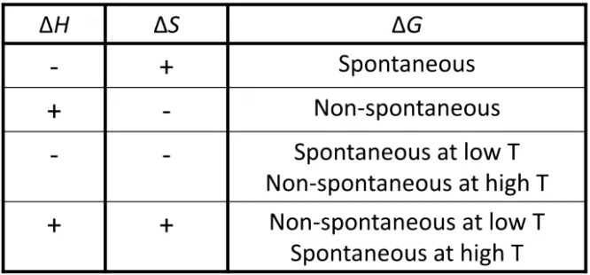

If a reaction has + heat on the right hand side, it is losing heat to the environment, so it is endothermic.

ΔG = sum ΔG (products) - sum ΔG (reactants)

ΔG⁰ = ΔH⁰ - TΔS⁰
Here, the ⁰ symbol signifies one bar.

ΔG tells you if a reaction is spontaneous forwards or backwards.

A single element has a ΔH⁰_{formation} of zero and a ΔG⁰_{formation} of zero. This is because it’s the same formation reaction forward and backwards. ΔS is also zero, but not the absolute value of S⁰.

When H2O and ethanol are combined, the net volume is actually lower because of hydrogen bonding making the bonds closer.

Every quantity in thermodynamics has a partial equivalent. Eg. partial volume, partial molar mass, partial G, etc.

Nov 19 Lecture:

We use mue to signify partial Gibbs free energy.

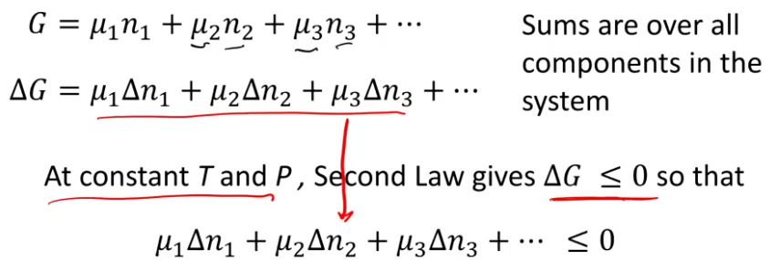

They expect us to understand qualitatively where all the equations come from, now how to quantitatively derive all of them. First Principles fun!

Materials move from higher to lower chemical potential until equilibrium is reached.

“Non-spontaneous means it won’t happen”

μ_{i} is partial Gibbs free energy.

Partial gibbs free energy of all particles in a system changes until net G is zero.

This equation below means that as temperature increases, mue decreases.
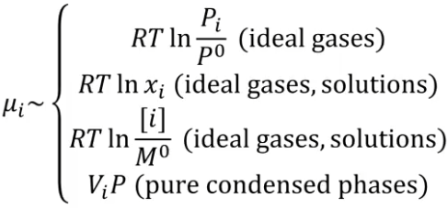

V_{i} is molar volume. P⁰ and M⁰ are standard state pressure and concentration.
Everything wants the lowest possible chemical potential.

If we plot mue vs. P (at fixed T), we get a graph that helps to describe the phase diagram.
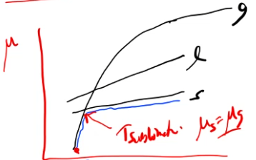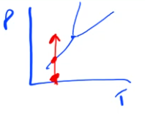

We can see phase transitions where the gas, liquid, or solid lines intersect. Because all reactions want the lowest possible chemical potential, they go for the line with the lowest slope.

The triple point happens when all three lines intersect on the mue vs. pressure graph.

You can imagine water (where the liquid phase is sloping left), where it would have liquid as the lowest line past the triple point.

Unlike this triple point example below:
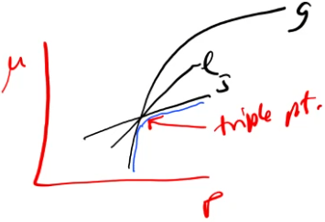

Notice that the gas line is logarithmic while liquid and solid are linear.

There are times when you can be on a higher line on the mue vs. pressure graph even though everything wants to be at the lowest possible chemical potential energy. An example is supercooled water, you’re liquid even though you want to be solid but it’s not being allowed for whatever chemical reason.

When you’re boiling the gas bubbles need something to form on. Impurities. This is why it’s possible to be on the liquid portion of the graph when it wants to be gas.

You can create graphs for constant pressure too, and the same principle as always being at the lowest possible chemical energy applies. You should be able to make graphs like this.
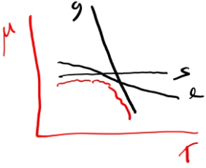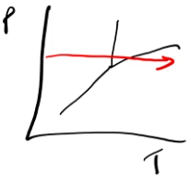

A mole fraction of 1 is a pure substance.

When you dissolve something in a liquid, its mole fraction goes down, and its chemical potential goes down (down the graph because mue decreases).

If μ_{products} < μ_{reactants}, then ΔG < 0 and reactants go to products. Spontaneous.
The opposite also applies if ΔG > 0 and if ΔG = 0.

You can calculate net ΔG using the mue method:
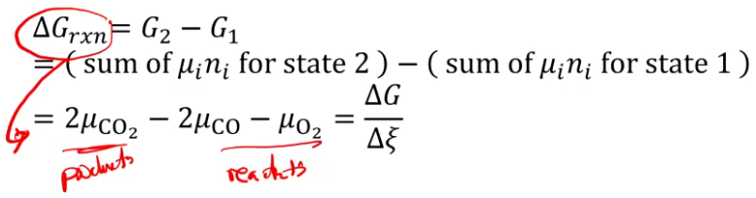

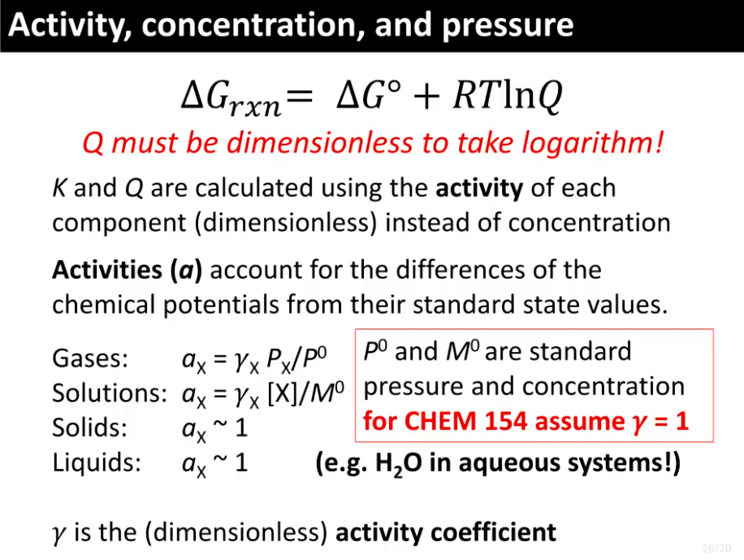
Final Studying
Learning to solve the problems of the last 4 weeks. No time for fundamentals.

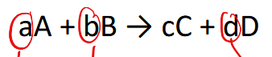
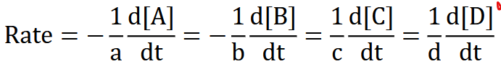

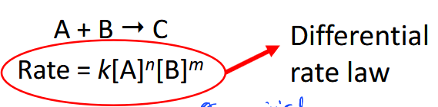

N and m are the order of the reaction. K is the rate constant. All experimentally determined.

To find rate from experimental data:
Compare rates from the default original state! Not just the previous state.
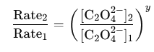

Gasses behave ideally at low pressure and high temperature

Bottom left = high radius
Top Right = Keff max
Opposites! High Radius = Low Keff <- intuitive
First order reaction half life: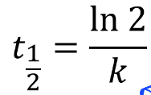

dG is free energy difference from the reactants to the products. Eg. for exothermic it’s positive. Right?

Arrhenius equation relates rate constant (k) to temperature:
